CO1 – ASSESSMENT TOOL 2

Name | SIDDARTH P
Register Number | 192324264
Slot | B
Subject Name | Data Handling and Visualization
Subject Code | DSA0603
Faculty In-Charge | Dr S Senthilvadivu

QUESTION 1 Mapping Data onto Aesthetics

1. Write an R program to create a scatter plot with Sales on the x-axis and Profit on the y-axis.
library(ggplot2)
sales_data <- data.frame(
Product = c("P1", "P2", "P3", "P4", "P5"),
Category = c("Electronics", "Clothing", "Furniture", "Clothing", "Electronics"),
Sales = c(120, 95, 150, 80, 135),
Profit = c(18, 12, 25, 8, 22)
)
ggplot(sales_data, aes(x = Sales, y = Profit)) +
geom_point(size = 3, color = "steelblue") +
labs(title = "Sales vs Profit",
x = "Sales (Rs. Lakhs)", y = "Profit (%)") +
theme_minimal()
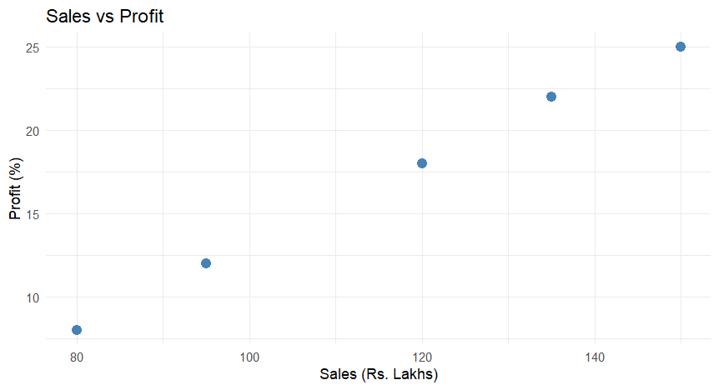

2. Map Category using an appropriate aesthetic and Sales using another suitable aesthetic.
ggplot(sales_data, aes(x = Sales, y = Profit,
color = Category, size = Sales)) +
geom_point(alpha = 0.8) +
labs(title = "Sales vs Profit by Category",
x = "Sales (Rs. Lakhs)", y = "Profit (%)",
color = "Category", size = "Sales") +
theme_minimal()
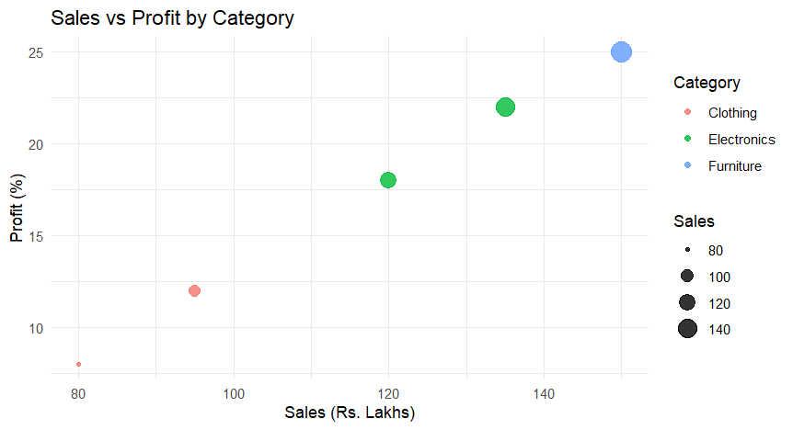

3. Interpret the relationship between Sales and Profit.
Answer: The scatter plot shows a clear positive relationship between Sales and Profit percentage — as Sales increase, Profit percentage also tends to increase. Products with higher sales figures such as P3 (₹150 Lakhs, 25%) and P5 (₹135 Lakhs, 22%) record the highest profit margins, while products with lower sales such as P4 (₹80 Lakhs, 8%) show the lowest profit margins. This suggests that higher-selling products are generally also the more profitable ones in this dataset, indicating a positive correlation between the two variables.
4. Identify the type of scale used for each variable.
Answer: Sales (₹ Lakhs) is measured on a continuous numeric (ratio) scale, as it represents a measurable quantity with a true zero. Profit (%) is also a continuous numeric (ratio) scale, since it is expressed as a percentage value. Category (Electronics, Clothing, Furniture) is measured on a categorical (nominal) scale, as it represents distinct, unordered groups rather than numeric values.
5. Suggest one alternative visualization that better represents the same data.
Answer: A grouped/clustered bar chart comparing Sales and Profit side-by-side for each product, or alternatively a bubble chart where bubble size represents Profit and color represents Category, would better represent the data — it would make it easier to compare profitability across categories at a glance while still preserving the individual product-level detail.

QUESTION 2 Coordinate Systems (Cartesian and Polar)

1. Write an R program to visualize the dataset using a Cartesian coordinate system.
library(ggplot2)
wind_data <- data.frame(
Direction = c("N", "NE", "E", "SE", "S", "SW", "W", "NW"),
Frequency = c(15, 10, 20, 12, 22, 8, 14, 9)
)
wind_data$Direction <- factor(wind_data$Direction,
levels = wind_data$Direction)
ggplot(wind_data, aes(x = Direction, y = Frequency)) +
geom_col(fill = "darkcyan") +
labs(title = "Wind Direction Frequency - Cartesian",
x = "Direction", y = "Frequency") +
theme_minimal()

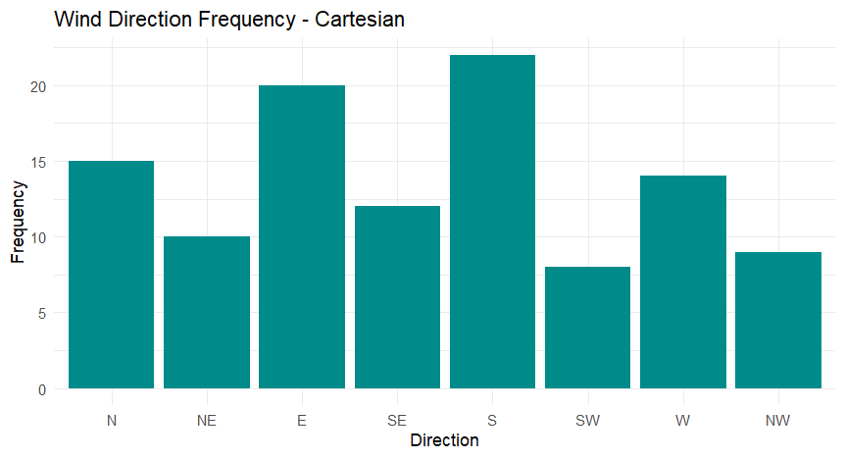

2. Write another R program to visualize the same data using a Polar coordinate system.
ggplot(wind_data, aes(x = Direction, y = Frequency, fill = Direction)) +
geom_col(width = 1) +
coord_polar(start = 0) +
labs(title = "Wind Direction Frequency - Polar",
x = "", y = "Frequency") +
theme_minimal() +
theme(legend.position = "none")
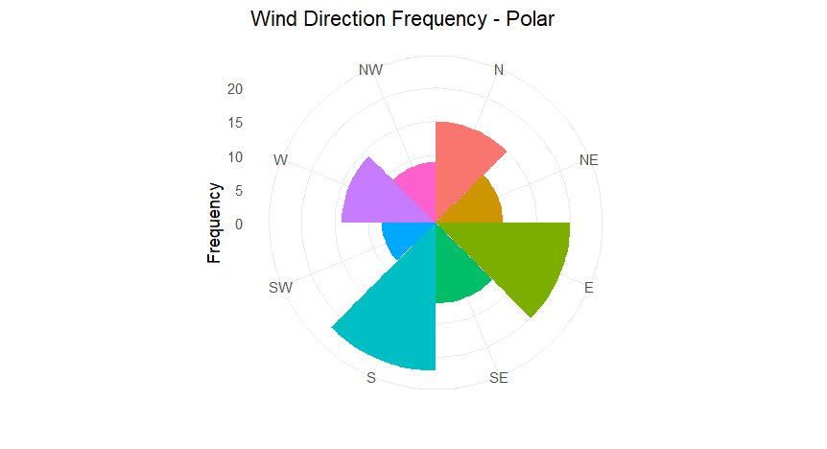

3. Compare the effectiveness of both visualizations.
Answer: In the Cartesian version (a standard bar chart), the frequencies for each direction are easy to compare precisely because bar heights are aligned on a common linear axis, making small differences easy to spot. In the Polar version (a wind-rose style chart), the same data is arranged radially around a circle, which visually mirrors real-world compass directions and makes the directional pattern easier to grasp intuitively, though precise numeric comparison between bars becomes slightly harder than in the Cartesian version.
4. Explain which coordinate system is more appropriate for directional data.
Answer: The Polar coordinate system is more appropriate for directional data such as compass directions (N, NE, E, SE, S, SW, W, NW), because it naturally represents the cyclical, 360-degree relationship between directions in a way that closely matches how directions are perceived in the real world.
5. Justify your answer based on data interpretation.
Answer: Directional data is inherently cyclical — North is adjacent to both NW and NE, and this circular relationship is lost when the categories are placed along a straight Cartesian axis, where they appear as simple unordered, disconnected categories. The Polar coordinate system preserves this angular continuity, allowing the viewer to correctly interpret which directions are neighboring and to visually identify the dominant direction(s) of frequency, such as S (22) and E (20), within their proper spatial context.

QUESTION 3 Color Scales for Data Representation

1. Write an R program to create a bar chart using a sequential color scale based on Marks.
library(ggplot2)
marks_data <- data.frame(
Student = c("A", "B", "C", "D", "E", "F"),
Marks = c(45, 55, 65, 70, 78, 90)
)
ggplot(marks_data, aes(x = Student, y = Marks, fill = Marks)) +
geom_col() +
scale_fill_gradient(low = "#DEEBF7", high = "#08306B") +
labs(title = "Student Marks (Sequential Color Scale)",
x = "Student", y = "Marks") +
theme_minimal()

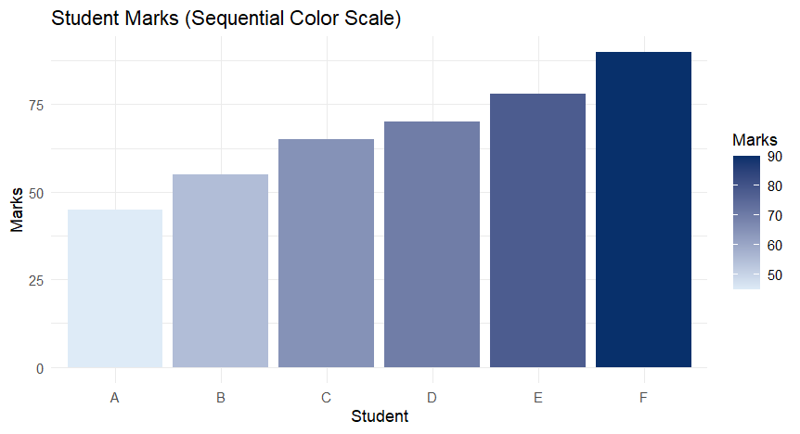

2. Identify the students with the highest and lowest marks from the visualization.
Answer: Student F has the highest marks (90), shown in the darkest shade of the sequential color scale, while Student A has the lowest marks (45), shown in the lightest shade.
3. Explain why a sequential color scale is appropriate.
Answer: Marks are continuous, ordered numeric data, so a sequential color scale — which progresses smoothly from a light shade to a dark shade of a single hue — is appropriate because it intuitively communicates the ordering and magnitude of the values. A viewer can immediately tell that a darker bar represents a higher mark, without needing to rely on the axis labels alone.
4. Suggest a color palette suitable for color-blind users.
Answer: Color-blind-friendly sequential palettes such as Viridis, Cividis, or the ColorBrewer "Blues"/"YlGnBu" palettes are suitable, as they are designed to remain distinguishable for common forms of color vision deficiency (e.g., deuteranopia and protanopia) while still preserving a clear light-to-dark progression.
5. Explain the difference between sequential and categorical color scales.
Answer: A sequential color scale uses graded shades of a single hue (light to dark) to represent ordered or continuous numeric data, where the intensity of color reflects magnitude. A categorical (qualitative) color scale, on the other hand, uses visually distinct, unrelated hues to represent unordered, nominal categories, where color differences indicate group identity rather than magnitude or order.

QUESTION 4 Highlighting with Color

1. Write an R program to create a bar chart highlighting the region with the highest revenue.
library(ggplot2)
region_data <- data.frame(
Region = c("North", "South", "East", "West"),
Revenue = c(750, 820, 690, 1010)
)
region_data$Highlight <- ifelse(region_data$Revenue == max(region_data$Revenue),
"Highest", "Other")
ggplot(region_data, aes(x = Region, y = Revenue, fill = Highlight)) +
geom_col() +
scale_fill_manual(values = c("Highest" = "firebrick", "Other" = "grey70")) +
labs(title = "Revenue by Region (Highest Highlighted)",
x = "Region", y = "Revenue (Rs. Crores)") +
theme_minimal() +
theme(legend.position = "none")

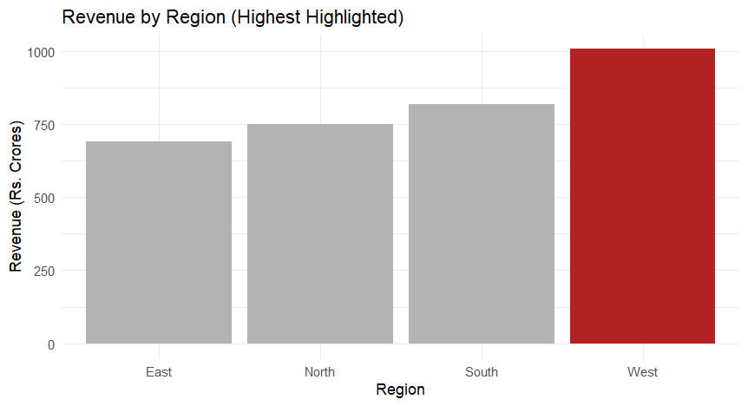

2. Explain how highlighting improves data interpretation.
Answer: Highlighting draws the viewer's attention immediately to the most important data point — in this case, the highest-revenue region — without requiring them to scan and compare every bar manually. It reduces cognitive load and speeds up interpretation by visually separating the key insight from the rest of the (comparatively neutral-colored) data.
3. Identify the highest-performing region.
Answer: West is the highest-performing region, with a revenue of ₹1,010 Crores, noticeably higher than all other regions.
4. Discuss how excessive use of colors can affect interpretation.
Answer: Using too many distinct colors across a chart can overwhelm the viewer, create visual clutter, and dilute the intended emphasis, making it harder to tell which element is actually meant to stand out. It can also unintentionally imply categorical differences or importance between values that don't actually exist, leading to a misleading or confusing interpretation of the data.
5. Suggest one alternative highlighting technique other than color.
Answer: Alternative highlighting techniques include using direct data labels or callout annotations on the key bar, increasing its size or adding a bold outline/border, or repositioning it (e.g., sorting bars in descending order) so that the important value naturally stands out through structure rather than color.

QUESTION 5 Integrated Visualization

1. Write an R program to create a bubble chart using appropriate aesthetic mappings.
library(ggplot2)
city_data <- data.frame(
City = c("A", "B", "C", "D"),
Region = c("North", "South", "West", "East"),
Population = c(5.2, 7.1, 9.4, 6.8),
AQI = c(150, 180, 90, 240),
Rainfall = c(1200, 950, 1400, 700)
)
ggplot(city_data, aes(x = Population, y = AQI,
size = Rainfall, color = Region)) +
geom_point(alpha = 0.8) +
scale_size(range = c(4, 14)) +
labs(title = "Population vs AQI (Bubble = Rainfall)",
x = "Population (Million)", y = "AQI") +
theme_minimal()

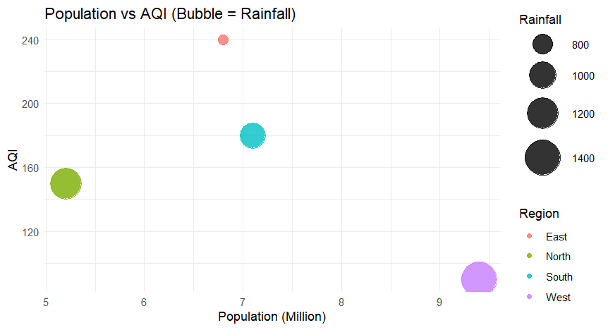

2. Select suitable aesthetics for Population, AQI, Rainfall, and Region.
Answer: Population (Million) can be mapped to the x-axis, AQI to the y-axis, Rainfall (mm) to bubble size, and Region to bubble color, since Region is a categorical variable best distinguished by distinct hues while Population, AQI, and Rainfall are all continuous numeric variables best represented through position and size.
3. Interpret the relationship between Population and AQI.
Answer: The relationship between Population and AQI is weak and inconsistent rather than strongly positive. City C has the highest population (9.4 Million) but the lowest AQI (90), while City D has a comparatively lower population (6.8 Million) but the highest AQI (240). This suggests that population size alone does not directly determine air quality — other factors such as region, industrial activity, or rainfall likely play a more significant role in influencing AQI.
4. Identify the continuous and categorical variables.
Answer: Continuous variables: Population (Million), AQI, and Rainfall (mm). Categorical variables: City and Region.
5. Recommend one improvement to enhance the visualization's readability.
Answer: Adding data labels for each city directly on the bubbles, or faceting the chart by Region into small multiples, would enhance readability by making it easier to identify individual cities and compare patterns within and across regions without relying solely on color and bubble size.

